Passport Seva Portal – Interaction Flaws and Redesign Solutions

Overview
This document identifies and analyzes three distinct interaction systems within the Passport Seva Portal that exhibit usability failures. Each system is treated independently, with a clearly defined user task, observed failure in the existing interface, and a corresponding conceptual redesign solution. The objective is to demonstrate how usability and interaction design improvements can be achieved without altering hardware constraints or removing any legal or administrative requirements.
The redesigns are presented as high‑fidelity conceptual prototypes intended for usability evaluation and academic analysis.

System 1: Service Selection & Appointment Entry

User Task
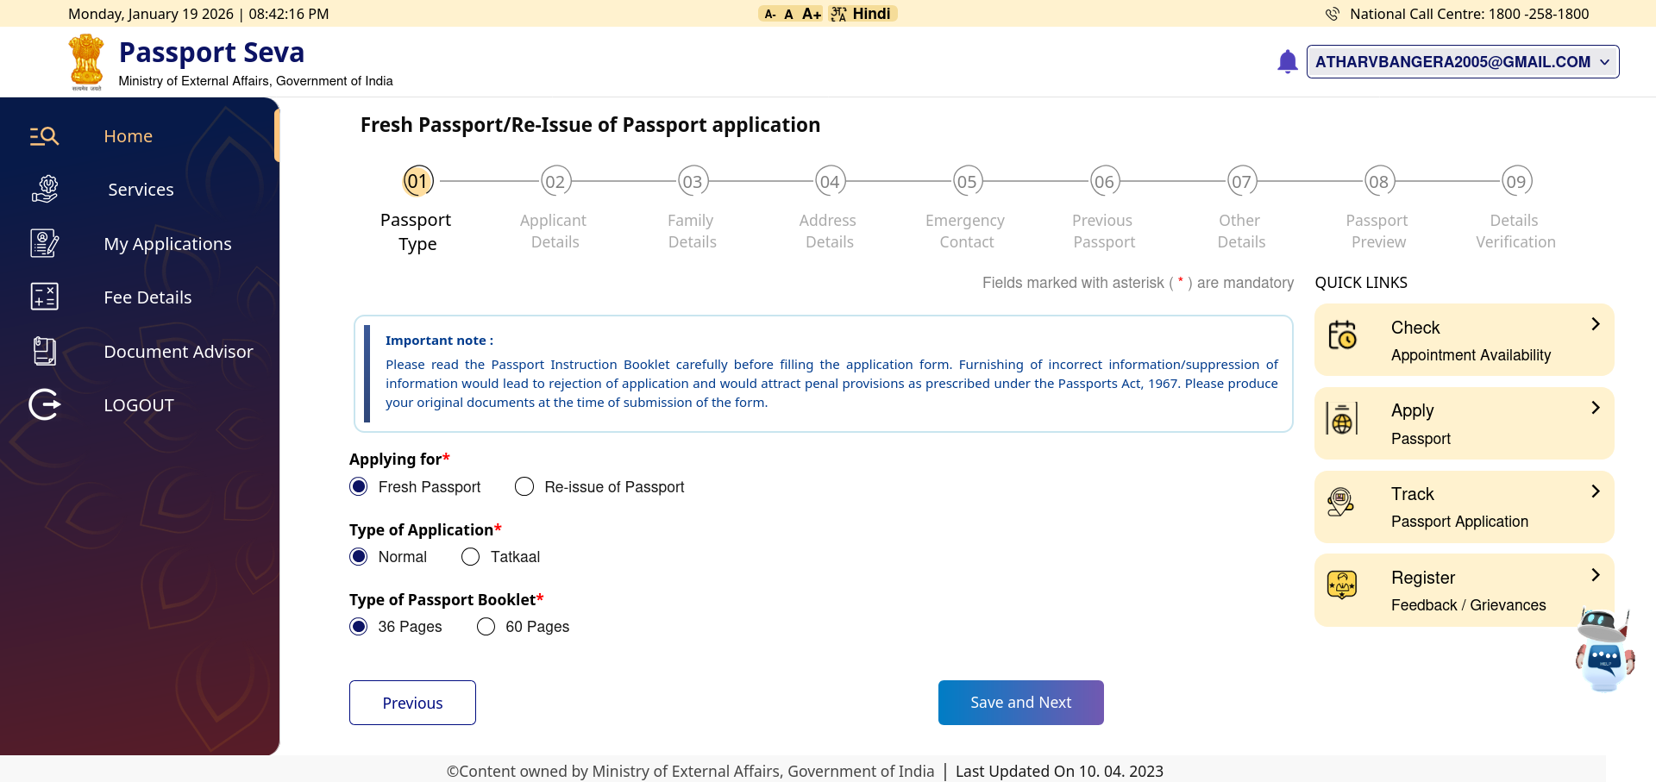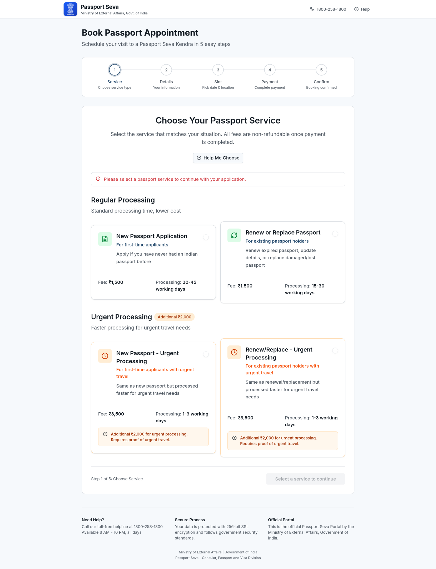
The user wants to understand which passport service to choose and proceed to appointment booking without making an irreversible mistake.

Observed Failure in Existing System
- Users are taken directly into a form without understanding service implications.
- Service options such as Fresh, Reissue, and Tatkaal are presented without sufficient explanation.
- Fee and processing‑time differences are not emphasized before commitment.
- Users may choose an inappropriate service and realize the mistake only after payment.

Impact on Users
- First‑time applicants experience confusion and anxiety.
- Elderly users hesitate or rely on external help.
- Increased likelihood of incorrect service selection.

Redesign Solution
- Introduced a decision‑first service selection screen before form entry.
- Grouped services by user intent (Regular vs Urgent).
- Displayed fees and processing timelines upfront.
- Disabled progression until a valid service is selected.

Outcome
Users understand service differences before proceeding, reducing incorrect selections and irreversible errors.

System 2: Personal Details Data Entry & Sequencing

User Task
The user wants to enter personal information correctly and confidently without confusion or fear of rejection.
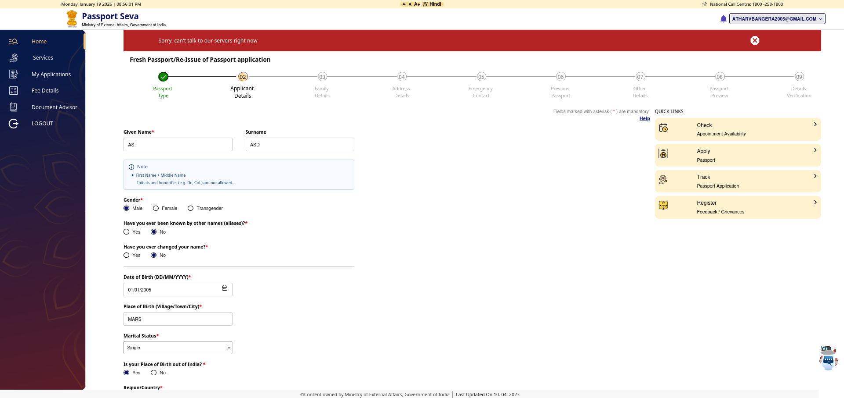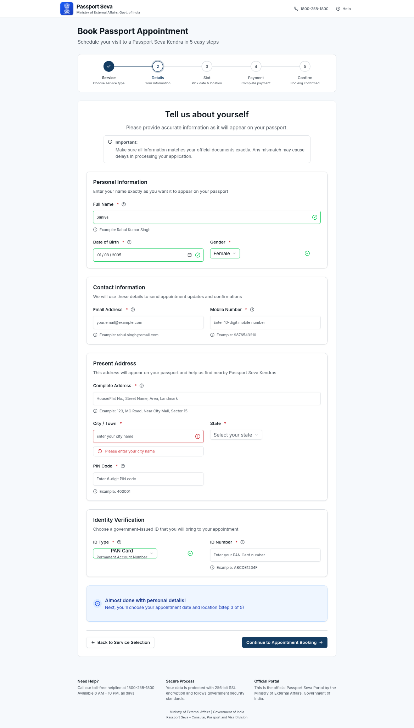

Observed Failure in Existing System
- Large numbers of unrelated questions are presented simultaneously.
- Advanced or conditional questions (e.g., alias, name change, Non‑ECR) appear early.
- Government terminology is used without explanation.
- No clear indication of which information will appear on the passport.

Impact on Users
- High cognitive load increases the probability of mistakes.
- Users do not understand the purpose of certain questions.
- Anxiety leads to slow completion or abandonment.

Redesign Solution
- Applied progressive disclosure, presenting only essential information first.
- Grouped fields into logical sections: Identity, Contact, Address, Verification.
- Added inline helper text explaining why information is required.
- Provided examples and context (e.g., “as printed on your passport”).

Outcome
The same data is collected, but in an order that matches human mental models, reducing confusion and errors.

System 3: Validation & Error Prevention Mechanism

User Task
The user wants to complete the application successfully and identify mistakes before final submission.
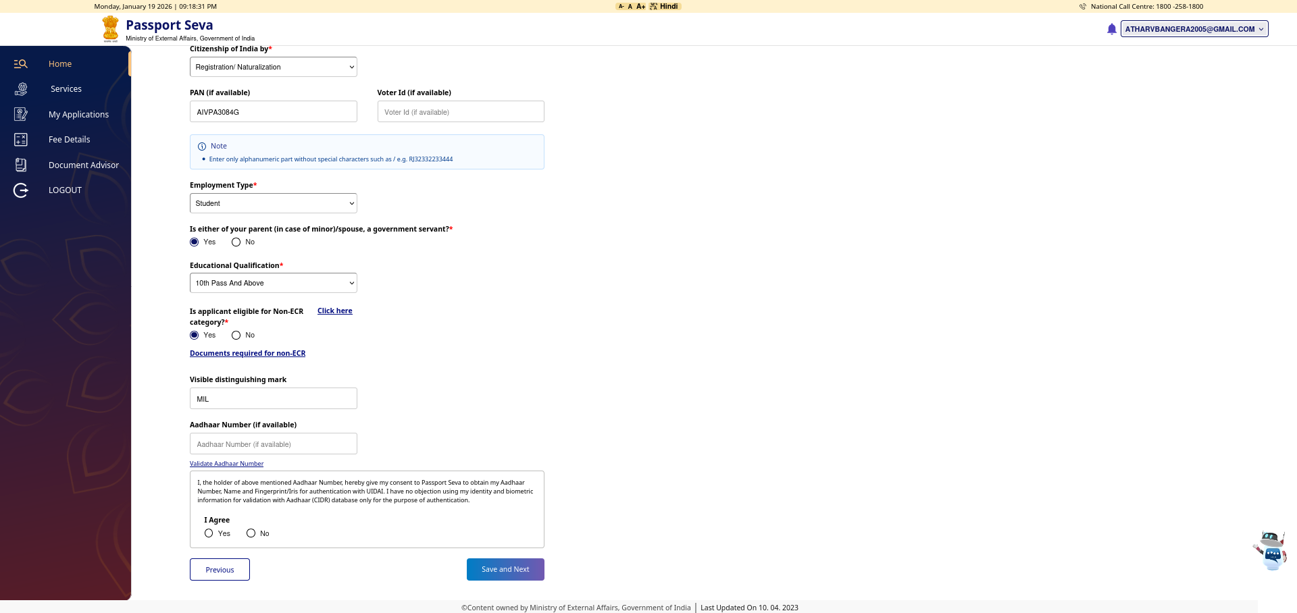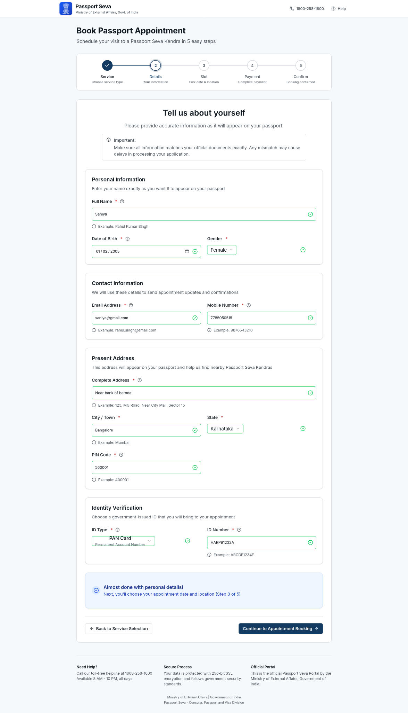

Observed Failure in Existing System
- Validation occurs after clicking “Save and Next”.
- Errors are displayed globally rather than at the field level.
- Users must navigate backward to fix issues.
- Consequences of errors (delays, rejections) are not clearly communicated.

Impact on Users
- Frustration due to repeated corrections.
- Increased risk of application rejection.
- Loss of confidence in system reliability.

Redesign Solution
- Introduced inline validation with immediate feedback.
- Disabled progression until mandatory fields are valid.
- Displayed clear, field‑specific error messages.
- Added warnings before irreversible actions, such as payment.

Outcome
Errors are prevented rather than discovered late, improving task success and user confidence.

Summary of Improvements
Interaction System | Core Failure | Redesign Focus | Result
Service Selection | Premature form entry | Decision clarity | Reduced wrong selections
Personal Details | Cognitive overload | Progressive disclosure | Fewer errors
Validation | Late error detection | Error prevention | Higher task success

Conclusion
The Passport Seva Portal contains multiple independent interaction systems, each with unique usability challenges. By addressing these systems individually and aligning interaction flow with user mental models, the redesign improves clarity, reduces anxiety, and prevents errors while maintaining all legal and system constraints. This approach demonstrates how usability improvements can be achieved through thoughtful interaction design rather than superficial visual changes.

